Minoan Society – Source Analysis Practice NAME:___________________________
Source 1
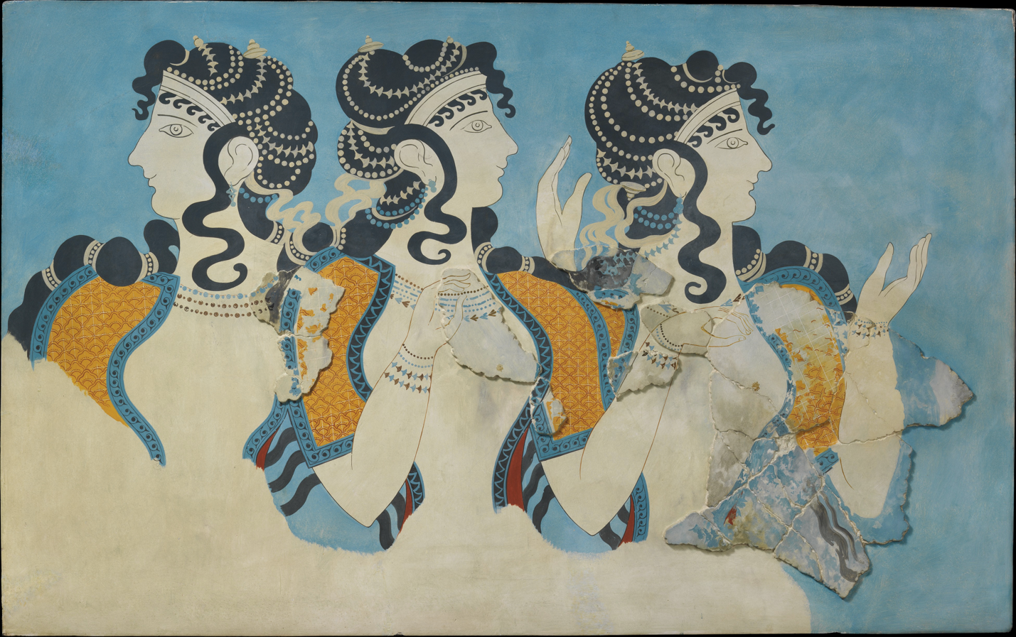

‘Ladies in Blue’ Fresco - 1525 - 1450BCE Excavated before 1914 from Knossos Palace

- Tick one (1) of the following in (a) and (b) to best describe Source 1. (1 marks)
      - written source ☐
      - archaeological source ☐
      - map/diagram ☐
      - reconstruction ☐
- Identify and discuss the historical context of Source 1. You should consider the following where appropriate: relevant event/s, significant person/people, key idea/s depicted in the source. (4 marks)
_____________________________________________________________________________________________________________________________________________________________________________________________________________________________________________________________________________________________________________________________________________________________________________________________________________________________________________________________________________________________________________________________________________________________________________________________________________________________________________________________________________________________________________________
Source 2
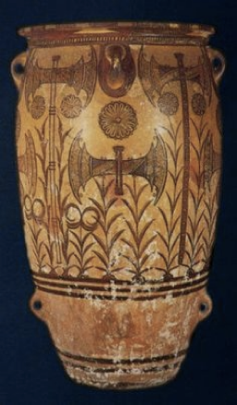

Minoan Art Labrys pithos – 1500BC Knossos Palace

- Tick one (1) of the following in (a) and (b) to best describe Source 1. (1 marks)
      - written source ☐
      - archaeological source ☐
      - map/diagram ☐
      - reconstruction ☐
- Identify and discuss the historical context of Source 1. You should consider the following where appropriate: relevant event/s, significant person/people, key idea/s depicted in the source. (4 marks)
____________________________________________________________________________________________________________________________________________________________________________________________________________________________________________________________________________________________________________________________________________________________________________________________________________________________________________________________________________________________________________________________________________________________________________________________________________________________________________________________________________________________________________________________________________________________________________________________________________________________________________________________________________________________________________________________________________________________
Source 3
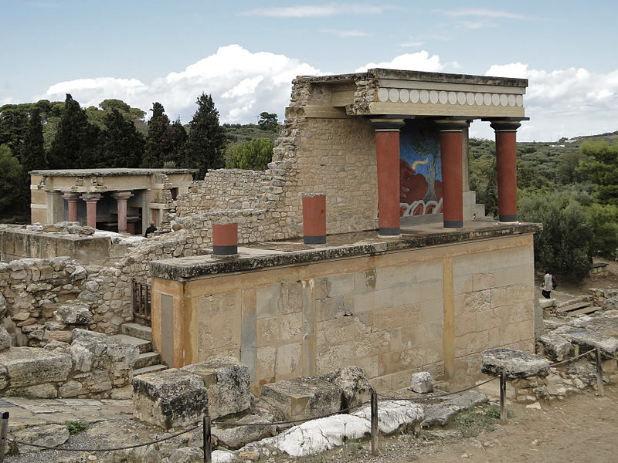

Knossos Palace - Restored North Entrance with charging bull fresco
- Tick one (1) of the following in (a) and (b) to best describe Source 1. (1 marks)
      - written source ☐
      - archaeological source ☐
      - map/diagram ☐
      - reconstruction ☐
- Identify and discuss the historical context of Source 1. You should consider the following where appropriate: relevant event/s, significant person/people, key idea/s depicted in the source. (4 marks)
_______________________________________________________________________________________________________________________________________________________________________________________________________________________________________________________________________________________________________________________________________________________________________________________________________________________________________________________________________________________________________________________________________________________________________________________________________________________________________________________________________________________________________________________________________________________________________________________________________________________________________________________________________________
Source 4
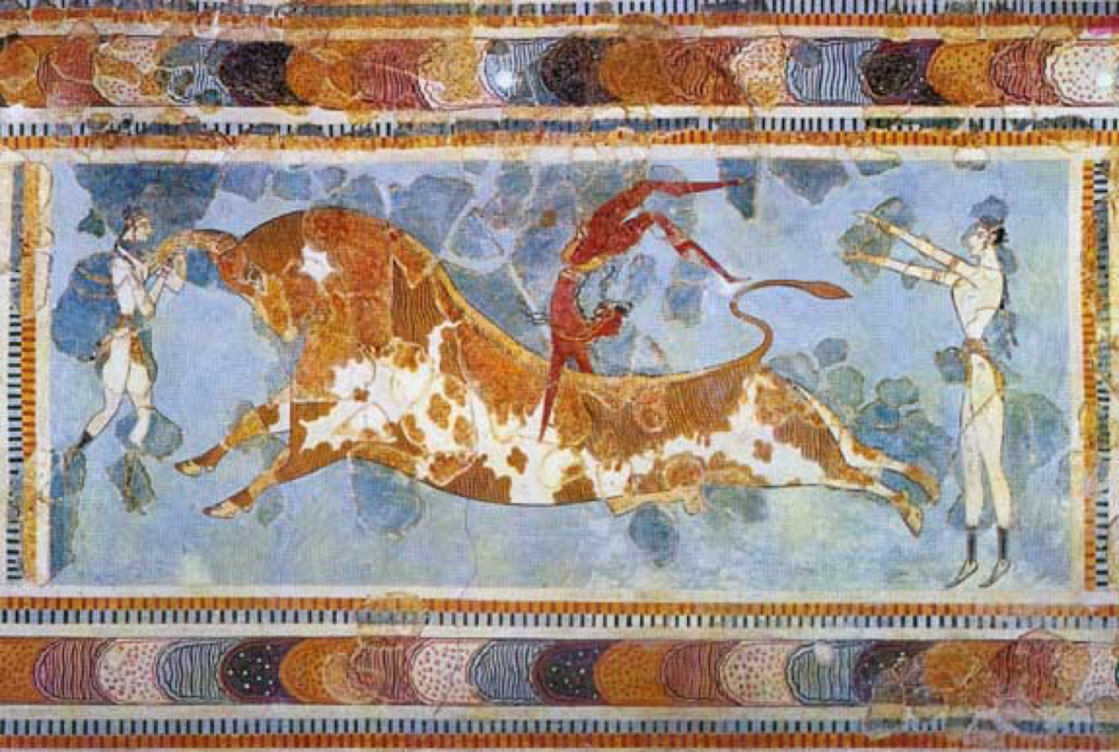

Bull-leaping fresco from the palace at Knossos

- Tick one (1) of the following in (a) and (b) to best describe Source 1. (1 marks)
      - written source ☐
      - archaeological source ☐
      - map/diagram ☐
      - reconstruction ☐
- Identify and discuss the historical context of Source 1. You should consider the following where appropriate: relevant event/s, significant person/people, key idea/s depicted in the source. (4 marks)
_______________________________________________________________________________________________________________________________________________________________________________________________________________________________________________________________________________________________________________________________________________________________________________________________________________________________________________________________________________________________________________________________________________________________________________________________________________________________________________________________________________________________________________________________________________________________________________________________________________________________________________________________________________

MARKING KEY

Student’s work being marked:_____________________________

Marker name:_______________________________________

- Tick one (1) of the following in (a) and (b) to best describe the source. (1 marks)
Source 1 | Archaeological | /1 mark
Source 2 | Archaeological | /1 mark
Source 3 | Reconstruction/ Archaeological | /1 mark
Source 4 | Archaeological | /1 mark

- Identify and discuss the historical context of Source 1. You should consider the following where appropriate: relevant event/s, significant person/people, key idea/s depicted in the source. (4 marks)
Description | Marks
Accurately identifies and discusses the historical context of the source, demonstrating a sound historical knowledge of the period. The answer includes discussion of: relevant event/s and significant person/people and key idea/s | 4
Identifies and briefly discusses the historical context of the source, demonstrating some historical knowledge of the period, but with omissions. The answer includes discussion of: relevant event/s AND/OR significant person/people AND/OR key idea/s | 3
Identifies and provides a simple description the historical context of Source 1, demonstrating a limited historical knowledge of the period. The answer includes discussion of: relevant event/s AND/OR significant person/people AND/OR key idea/s | 2
The answer demonstrates little historical knowledge of the period, with very simple description of: One (or two) of the criteria mentioned OR t he answer is factually inaccurate, or the answer simply describes the source | 1

Source 1 | Source 2 | Source 3 | Source 4
Importance of women in society  Social Roles/hierarchy  Equal between sexes  Gods AND goddesses worshipped | No people depicted but shows importance of war/weaponry with labrys  Labrys used in society  Agricultural society - wheat | Palace at Knossos home of king minos – ruler of Minoans  Significance of bull  Palaces as centre of society  Palace as status symbol | Roles of men and women in society  Significance of bull  Myth of minotaur  Rituals in society

